Light COOL 'N EASY Pie

Prep Time: 15 min

Total Time: 4 hr 30 min 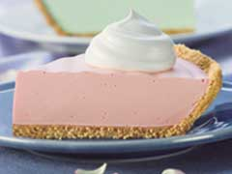
Makes: 8 servings

2/3 cup boiling water
1 pkg. (4-serving size) JELL-O Brand Sugar Free Low Calorie Gelatin, any flavor
Ice cubes
1/2 cup cold water
1 tub (8 oz.) COOL WHIP FREE Whipped Topping, thawed, divided
1 ready-to-use reduced fat graham cracker crumb crust (6 oz. or 9 inch)

STIR boiling water into dry gelatin mix in large bowl at least 2 minutes until completely dissolved. Add enough ice to cold water to measure 1 cup. Add to gelatin; stir until slightly thickened. Remove any unmelted ice.

ADD 2 cups of the whipped topping; stir with wire whisk until well blended. Refrigerate 10 to 15 minutes or until mixture is very thick and will mound. Spoon into crust. Refrigerate 4 hours or until firm.

TOP with remaining whipped topping just before serving. Store leftover pie in refrigerator.

Nutrition (per serving)

Calories 150 Total fat 5g Carbohydrate 25g

